**Introduction**

**Ib** = design current

**In** = Protective/fuse rating breaker size

**Iz** = Cable rating

**NOTE: I stands for current. Ib In and Iz are all current based.**



Simple example:

* Heater has a design current of 5
* needs to have a fuse of 6
* and a cable rating of 7.2.

**Tutor aside:** Always have leeway when it comes to **Ib**, **In** and **Iz**. For example, it says “less than or equal to”. make sure it is always greater than. As shown in this example.

**Ib​ – Design current:** The actual current that the load is expected to draw under normal operation.

**In​ – Nominal current:** of the protective device: The rated current of the circuit breaker or fuse (e.g., a 16 A MCB).

**Iz​ – Current-carrying capacity:**(ampacity) of the cable or conductor, under the given installation conditions.

**START FIRST PRACTISE**

**Question:**

If we run a cable in a 30 degree room.

With a Twin and Earth 70 degrees.

Grouped with 7 cables with 320mm insulation

And a **32 A** breaker.

**Workings out:**

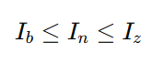

**Ib** = design current

**In** = Protective/fuse rating breaker size

**Iz** = Cable rating

The **first step** is to calculate the design current => **Ib**.

**Ib** = ??

The **second step** is to calculate the breaker size => **In**

**In** = **32 A** breaker.

The **third step** is to calculate **Iz** => cable rating;

* The pre-requisite is to calculate **It** => current carrying capacity**.**

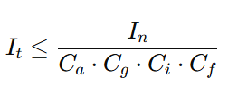

* The base formula to deduce **It** => current carrying capacity.

**Ca => ambient temperature**

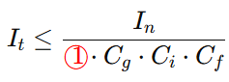

* **Ca** - The ambient temperature is deduced as 1 from **Table F1** on **page 168**.

**Cg => grouping**

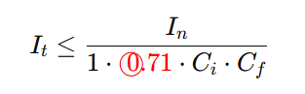

* **Cg**- is deduced as 0.71. Because there are seven cables in the wall. So this additional cable makes 8.

**Ci => thermal insulation**

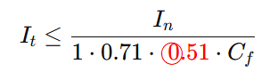

* **Ci**- is deduced as 0.51. Because the question states “320mm insulation” which, when rounded up to 400. Corresponds to 0.51 Derating factor (Ci ).

**Cf => account for 3036 fuse box**

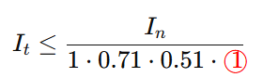

* **Cf**- is deduced as 1. As the on guide site states “for all other devices **Cf = 1**. ”

**In => represents the current at which the protective device is designed to operate in order to protect the circuit from damage.**

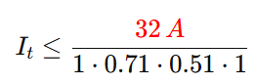

* **In**  - The question gives us the breaker size as **32 A**

Therefore **It** ,

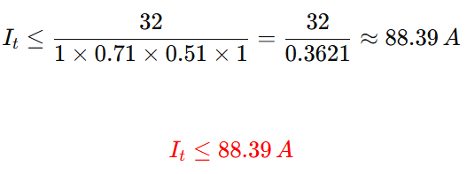

**END FIRST PRACTISE**

**START SECOND PRACTISE**

**Question:**

**In** is 45. The total answer is 63.

A shower is running through **100mm insulation**. Which has a **70 degree** thermoplastic cover. The cable is fitted into an enclosed wall with 6 circuits. The shower requires **7.2 kW** to run and uses **230 volts**.

The temperature of the bathroom is **25 degrees**.

Finally, Sam’s fuse box has not been updated in a while and is **version 3036**.

**Workings out:**



* **Ib = design current**
* **In = Breaker Size**
* **Iz = cable rating**

The **first step** is to calculate the design current => **Ib**.

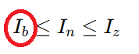

* To calculate the design current (**Ib**) we use the **PIV formula triangle**;
* The answer for **Ib** will be measured in amps.

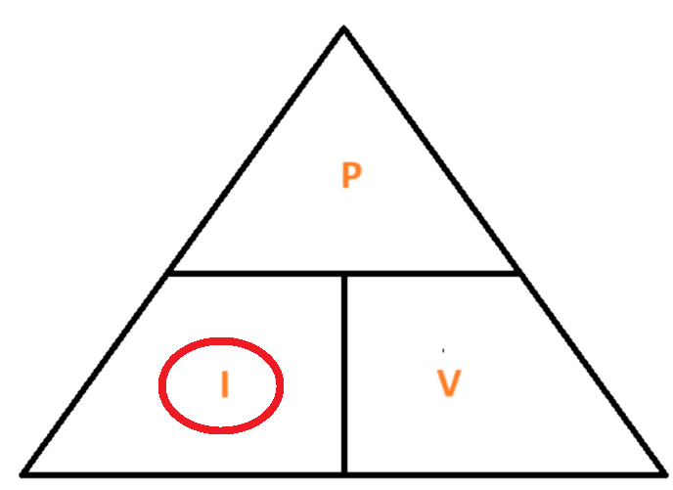 **PIV formula triangle**

* I = P / V or
* Current = Power / Voltage;
* 7.2 kW / 230 volts = 31.30 amps.
* 7,200 / 230 = 31.30 A

**Diversity rule check**

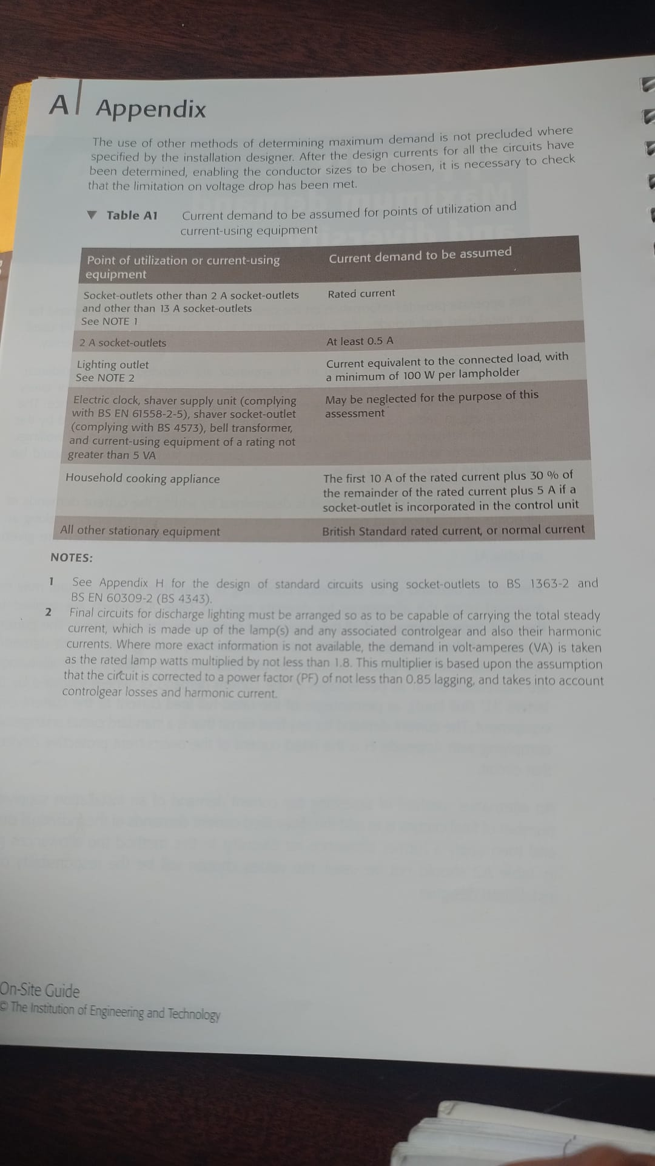

* **For Ib  (the design current) check if the appliance appears on table A1 on page 136;**
* **If yes, apply the diversity calculation;**
* **In this instance a shower does not appear on the table;**
* **So Ib = 31.30 amps.**

The **second step** is to calculate the breaker size => **In**

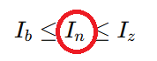

* To calculate **In** read the Header row on **Table B1** (page 140);
* We must calculate the right sized breaker to use;

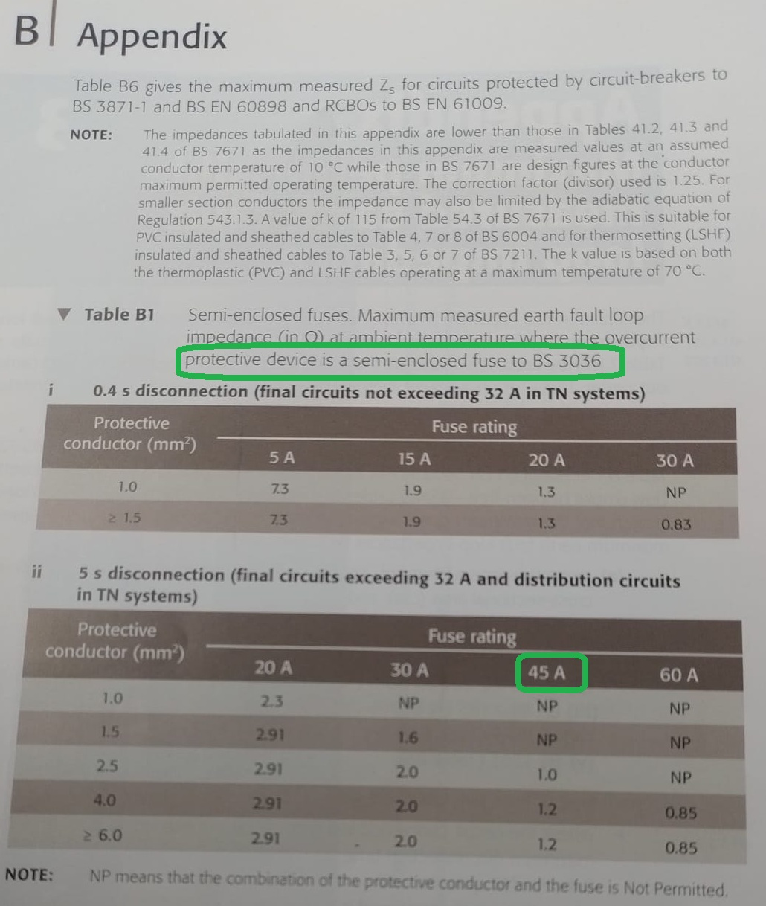

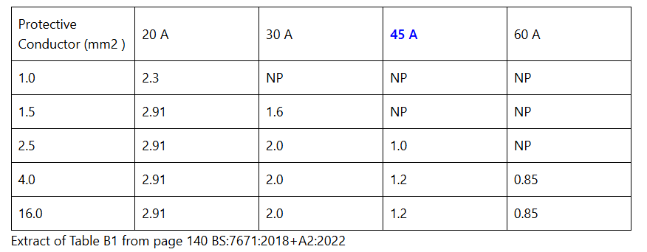

* The design current (**Ib**) has been calculated as **31.30 amps** - as deduced in the **first step**;
* Round up to the nearest value in the header row table **Table B1** (page 140);
* From the table we can conclude that the right breaker size is **45 A** for a design current (**Ib**) of **31.30 amps**;
* 30 A and 20 A are too small. 60 A is too large
* Note that we highlighted **“protective device is a semi-enclosed fuse to BS 3036”**

The **third step** is to calculate **Iz** => cable rating;

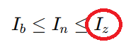

* To calculate **Iz** => cable rating;
* We must first calculate **It** => current carrying capacity.

**It => current carrying capacity formula**

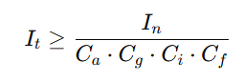

* The above formula is used to calculate **It**;
* From **It** we can deduce the value of **Iz**;
* Use **page 167** to calculate **Ca, Cg, Ci and Cf**

**Ca => ambient temperature**

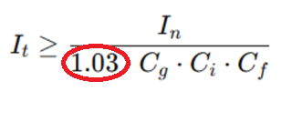

* Calculate **Ca** first;
* We know that the Ambient template is 25 degrees and the insulation is 70 degrees;
* Hence, in **Table F1** on **page 168** the answer is 1.03.

**Cg=> grouping**

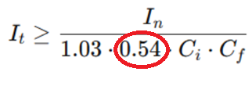

* We calculate **Cg** because of the **Table F3** on **page 170**;
* The question states 6 cables already situated into the wall;
* Therefore this additional cable will make it **seven**.

**Ci => thermal insulation**

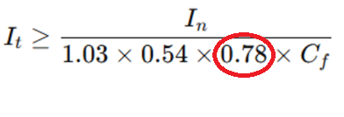

* **Ci** is deduced from **Table F2** on **page 169**;
* **Ci** - factors in how insulation around a cable can affect its ability to dissipate heat and thus impact on the maximum amount of current that it can safely carry;
* The text informs us that the length of the insulation is 100mm this equates to 0.78.

**Cf => account for 3036 fuse box**

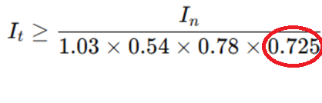

* **Cf** is deduced from **page 167** at the bottom of the page;
* The answer is 0.725;
* This number is deduced from the text “a semi-enclosed fuse to BS 3036”.

**In => represents the current at which the protective device is designed to operate in order to protect the circuit from damage**

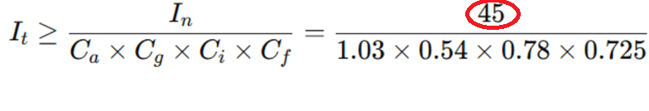

* **In** has been deduced from the **second step** to be **45 A**;
* Because, we deduced the breaker size **(In)** based on the design current **(Ib)**;
* If the current exceeds **45 A** then the breaker device will operate.

It = 143.1A

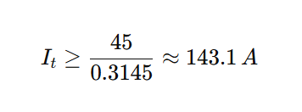

**IZ** - Cable size. We need a cable size that can carry a **143.1 A** current flow.

As mentioned in the question. We already have **6 circuits**. With this addition, t**here will be 7 circuits.**

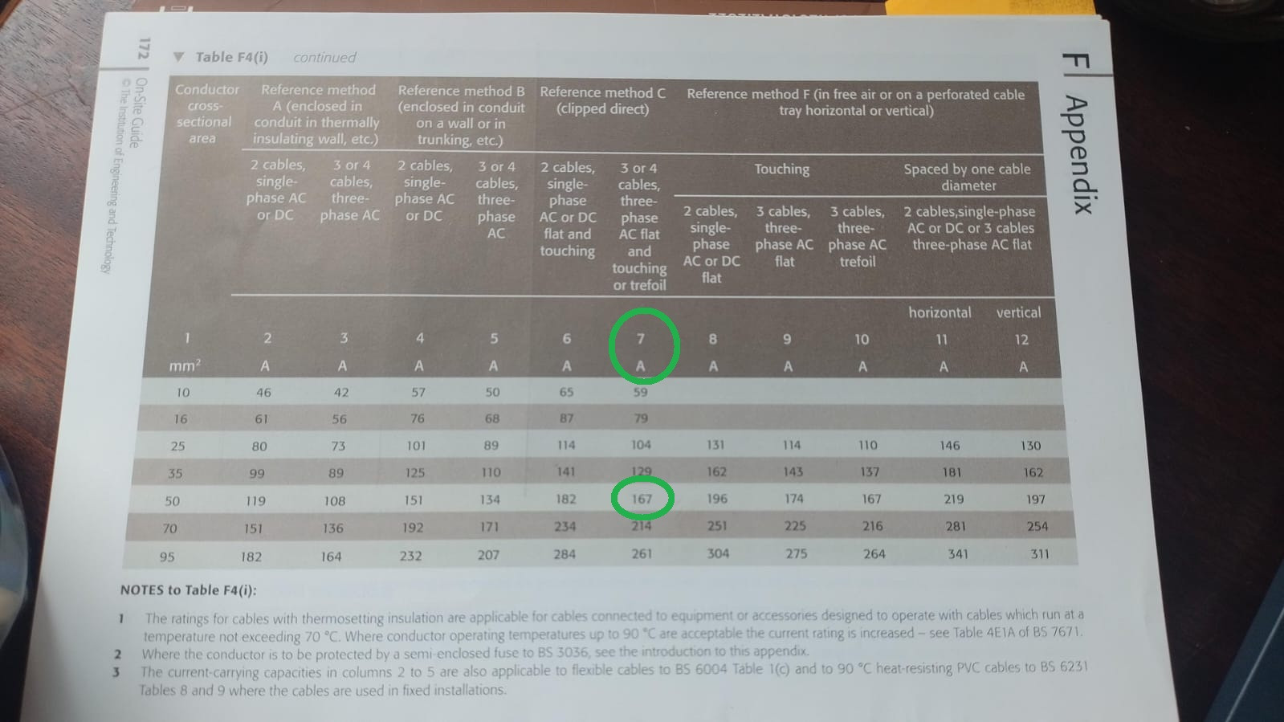

**END SECOND PRACTISE**

**Voltage drop**

**Introduction**

Zs = Ze + (R1+R2)

Zs = Earth Fault Loop Impedance (EFLI)

Ze = Connection from fuse box back to transformer

(R1+R2) = Line + CPC resistance. Internal from the circuit to the fuse box

R1 = Live

R2 = Earth

Z = Impedance

(R1 + R2)

**Question**

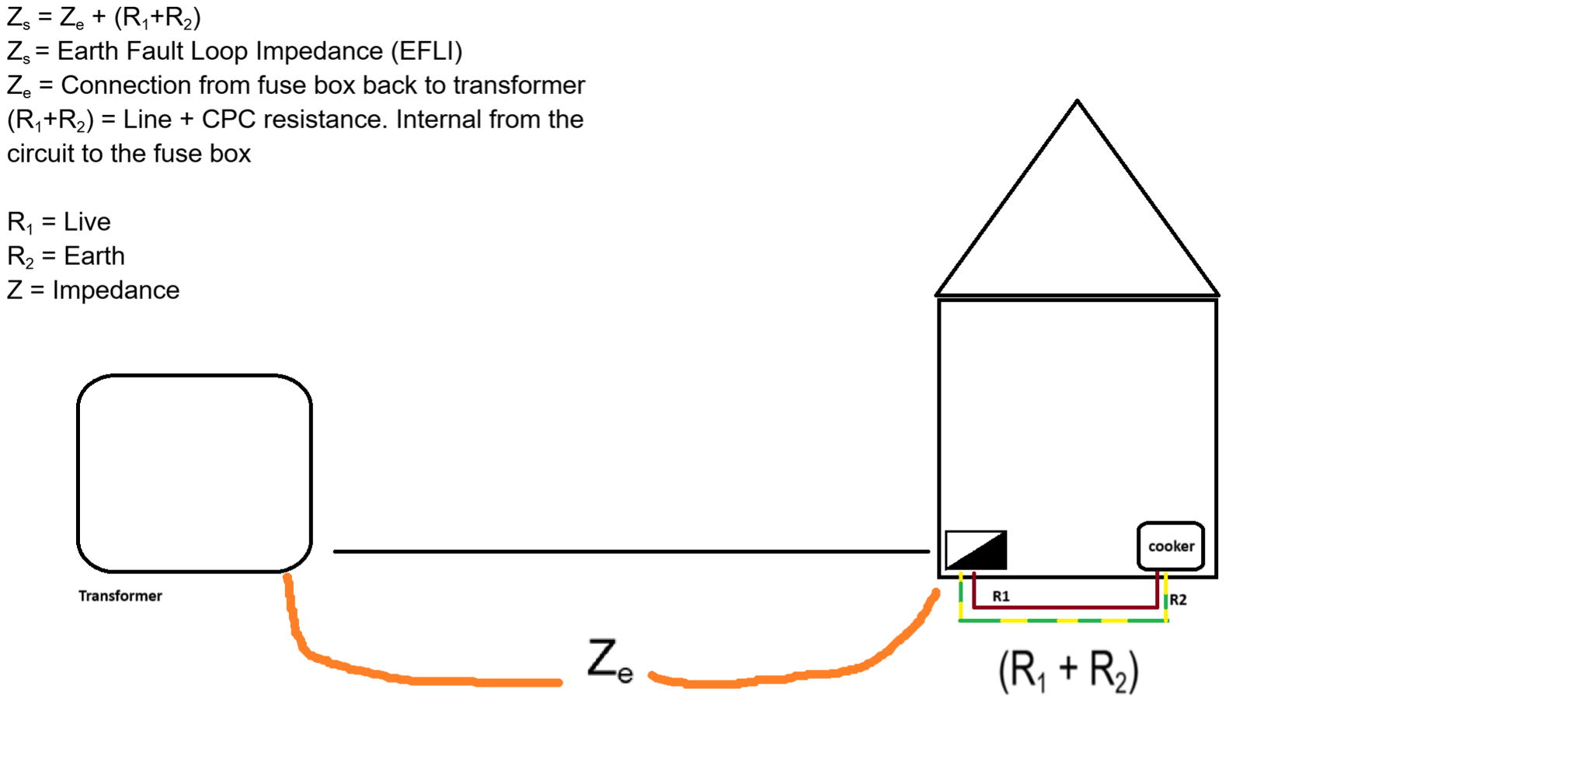

**Working out**

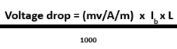

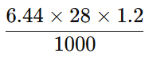

**= 0.22 Ω**

**=> Zs = Ze + (R1 + R2)**

**=> 0.22 + 0.09**

**=> 0.31 Ω**

**230 / 0.31 = 741.94 A (will flow in an event of a fault)**